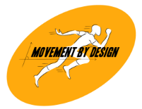
S&C FOLLOW-UP SHEET
Date: ____/____/________
Patient Name: __________________________________________________ Patient ID: _______________
Age: _________ Sex: __________ Dominance: __________ Contact no.: __________________________
Occupation: ___________________ Sport: _______________________________________________________
Address: ______________________________________________________________________________________
Attending Coach / Physiotherapist: ___________________
Emergency Contact Information:
Name: _____________________ Contact no.: ____________________ Relationship: ____________________

Body Wt.: _______ kg | BMI: _______ kg/cm² | SpO_{2: __________} % on ______
Height: _______ cm | PR: _______ bpm | BP: ______/_____ mmHg

Comorbidities: DM HTN CAD PCOS Thyroid issues ( / ) Other: _____________________
Primary Goal: __________________________________________________________________________________
Current/Past Injuries: ___________________________________________________________________________

No. | Date | Exercises | Load | Volume |  |  | RPE | Remark | Sign

Patient Name: ______________________________ Goal: ____________________________________________
No. | Date | Exercises | Load | Volume |  |  | RPE | Remark | Sign

